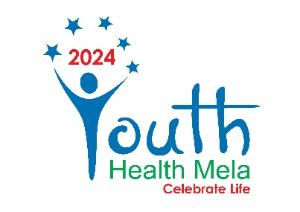
Youth Health Mela
15th Feb – 17th February 2024
23rd

Application Template for Concept Note
(Please read the guidelines before filing the application)

Name of the Organization
Presenter(s)
Address for communication
Landline No.
Mobile No.
Email Id:
Title of Proposed stall:
Focus Area:
Brief Description (250 words)
Please give a brief description of your mode of presentation (Atleast one demonstration or activity is mandatory)

Specific requirements (if any)
Expected Outcome
(Behaviour/Policy change)

Abstracts can be submitted via email to yhm.cancerinstitute@gmail.com or by post to the event secretariat.

Last date for abstract submission – 5th January 2023

Event Secretariat: Cancer Institute (WIA), No.38, Sardar Patel Road, Adyar, Chennai – 20

